**Day 3:**

**Get the IP address of guvi.in**

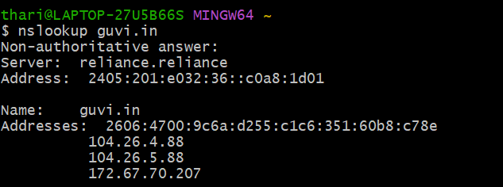

**CPU/memory**

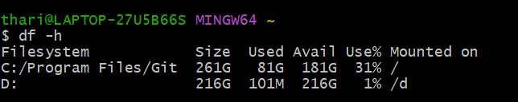

**Ping**

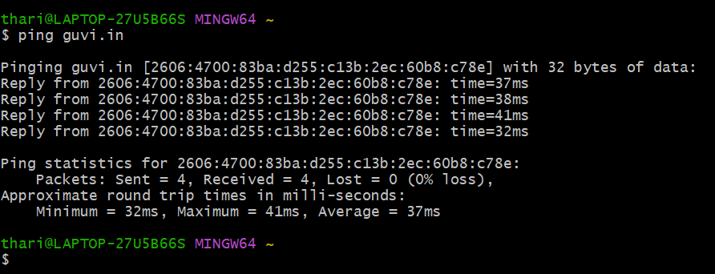

**Port check:**

